Table of Contents

1 Technical Staff Module User Manual

1.1 1. Role Objective
Technical Staff (Employee) execute assigned tickets, deliver technical resolution, escalate when necessary, and submit complete closure evidence for supervisor approval.

1.2 2. Module List (Technical Staff)
- Login
- Dashboard
- Assigned Tickets
- Escalation History
- Knowledge Hub
- Reports
- Settings
- Notifications

1.3 3. Login Module
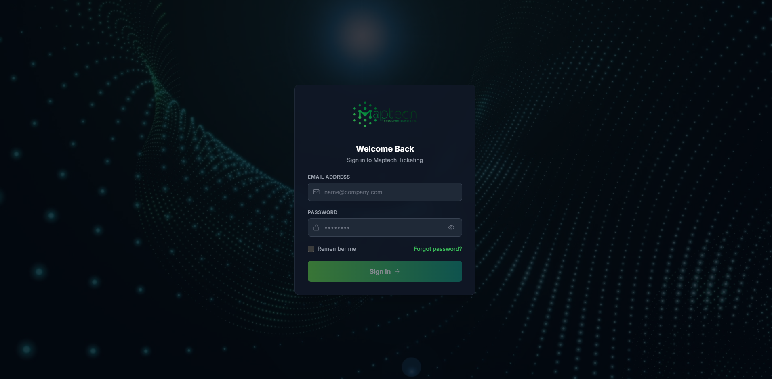
Technical Login
Steps: 1. Enter employee credentials. 2. Click Sign In. 3. Confirm redirect to Technical dashboard.

1.4 4. Dashboard Module
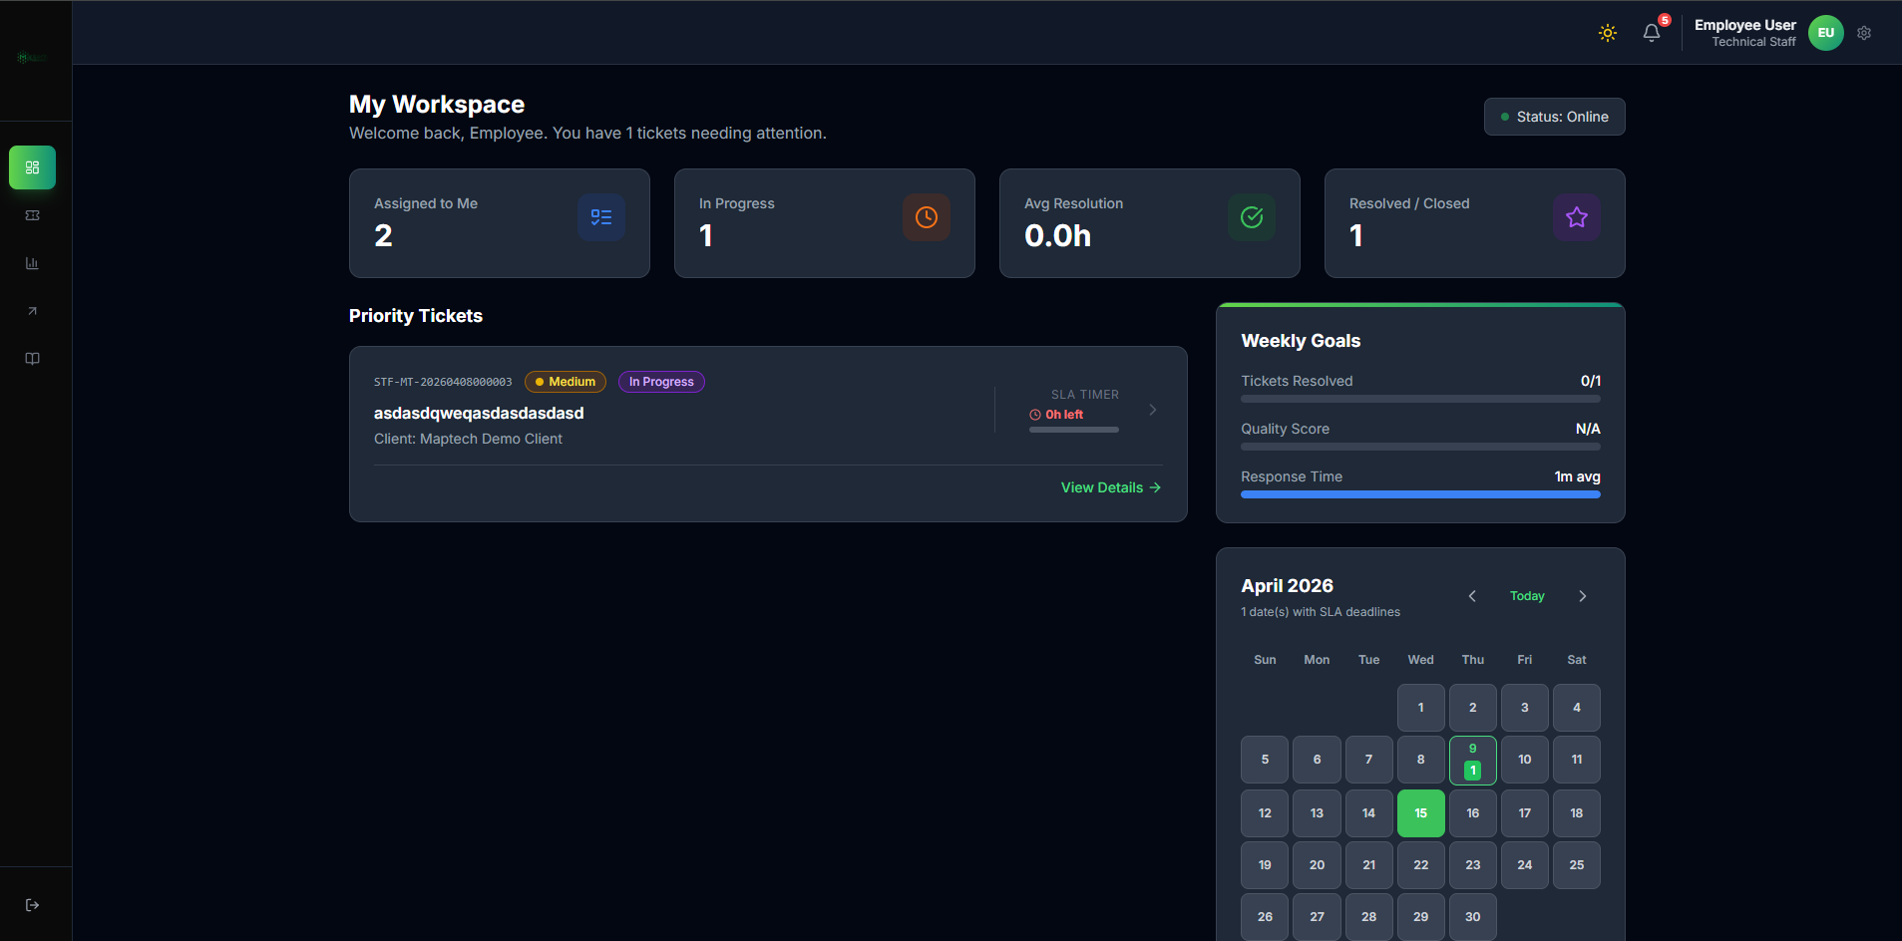
Technical Dashboard
Purpose: - View assigned workload, in-progress work, and weekly goals. - Check urgent SLA and priority indicators.
Daily Checklist: 1. Open top-priority assigned ticket first. 2. Confirm status and SLA urgency. 3. Open ticket details and begin documented work.

1.5 5. Assigned Tickets Module
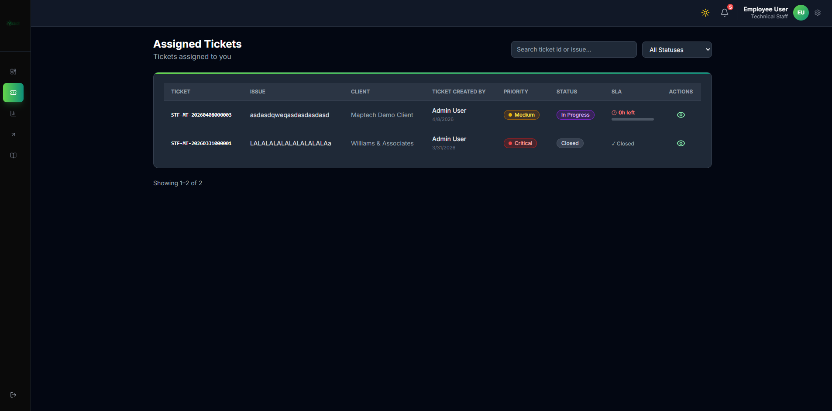
Technical Assigned Tickets
Purpose: - Main work queue for all tickets assigned to current technical user.
Steps: 1. Filter by status when needed. 2. Open ticket details from action column. 3. Begin or continue execution based on current ticket state. 4. Move ticket toward closure by updating findings, action details, and proof evidence.

1.5.1 5.1 Resolving Ticket in Assigned Tickets Module
Resolution Line A1: Open assigned ticket and confirm problem statement.
Resolution Line A2: Start or continue In Progress work.
Resolution Line A3: Record diagnosis and action taken clearly.
Resolution Line A4: Update required ticket fields before requesting closure.
Resolution Line A5: Upload proof evidence that demonstrates resolution.
Resolution Line A6: Submit closure request and wait for supervisor review.

1.6 6. Technical Execution Workflow (Core)
Execution Flow Lines: - Flow Line T1: Receive assignment notification. - Flow Line T2: Open assigned ticket and review issue context. - Flow Line T3: Start work (In Progress) and begin diagnosis. - Flow Line T4: Update ticket work fields and remarks during troubleshooting. - Flow Line T5: Upload proof attachments for actions performed. - Flow Line T6: Request closure when solution is complete. - Flow Line T7: Wait for supervisor review and closure confirmation.

1.6.1 6.1 Closure Readiness Checklist (Technical)
Checklist Line C1: Action notes are complete and clear.
Checklist Line C2: Remarks explain final system condition.
Checklist Line C3: Evidence files are attached and readable.
Checklist Line C4: Ticket fields are updated to match actual result.
Checklist Line C5: Closure request is submitted only when issue is resolved or properly documented for observation.
Escalation Branch Lines: - Flow Line E1: If scope exceeds capability, escalate internally. - Flow Line E2: If reroute to another technician is needed, pass ticket appropriately. - Flow Line E3: If external support is required, submit external escalation with vendor/distributor name and escalation notes.
Observation Branch Lines: - Flow Line O1: If issue requires monitoring, submit for observation. - Flow Line O2: Resume active work when monitoring results require action.

1.7 7. Escalation Module
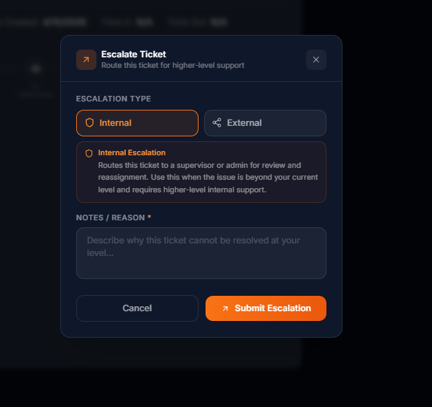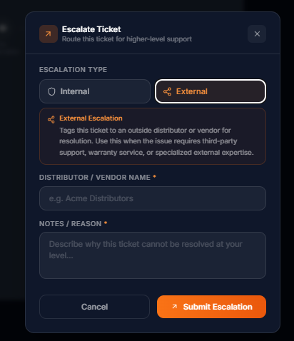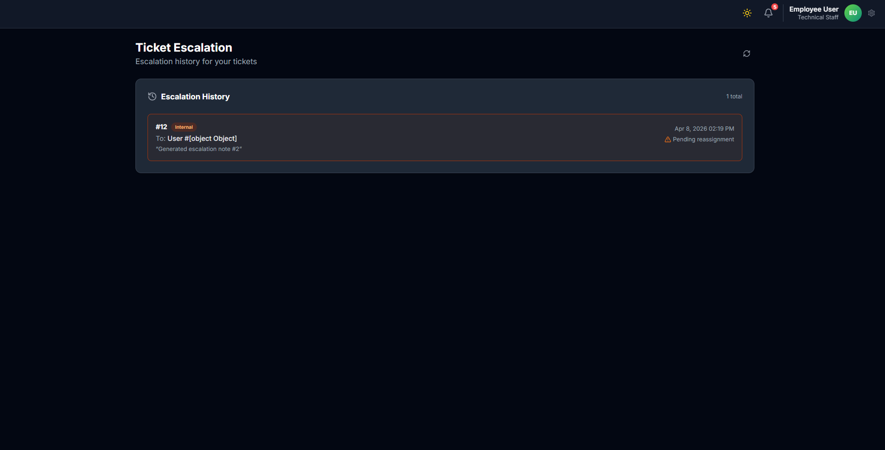
Purpose: - Submit and track internal escalation, pass, and external escalation records for assigned tickets.
Steps: 1. From ticket actions, choose Escalate or Pass when issue cannot be completed in current assignment. 2. For internal escalation, provide clear escalation notes. 3. For pass flow, select target technician and provide pass notes. 4. For external escalation, enter vendor/distributor name and escalation notes. 5. Submit action and review resulting status/assignment updates in Escalation History.
Escalation-to-Resolution Lines: - Flow Line ER1: Escalate ticket when resolution cannot be completed at current level. - Flow Line ER2: Use pass flow when reassignment to another technician is needed. - Flow Line ER3: For external escalation, provide vendor/distributor name and notes. - Flow Line ER4: Monitor reassignment or external-tracking outcome. - Flow Line ER5: Resume work if ticket returns to you and continue toward closure.

1.8 8. Knowledge Hub Module
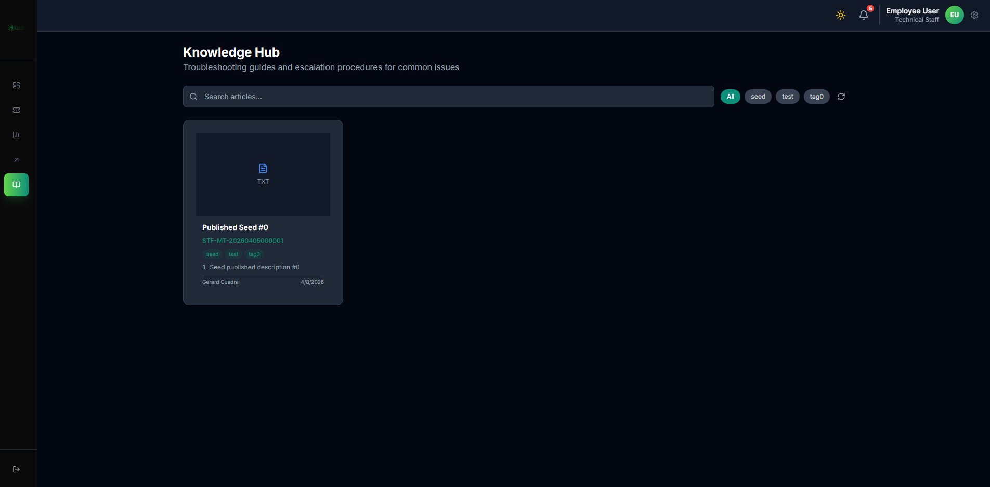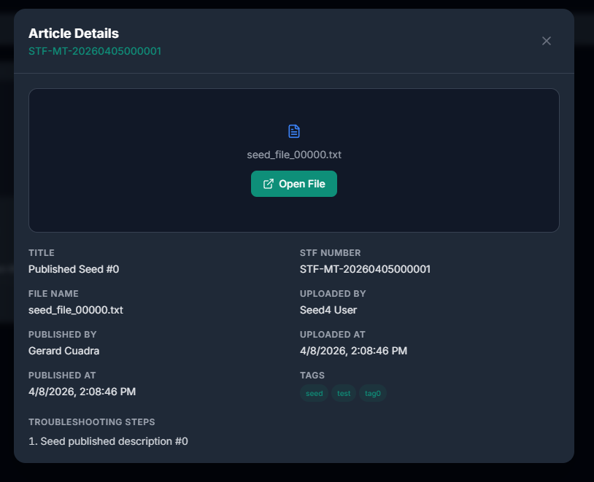
Purpose: - Reuse published solutions for faster diagnostics and resolution.
Usage Steps: 1. Search using issue keywords/tags. 2. Open relevant article. 3. Apply troubleshooting steps to current ticket. 4. Reference successful patterns in your work notes.

1.9 9. Reports Module
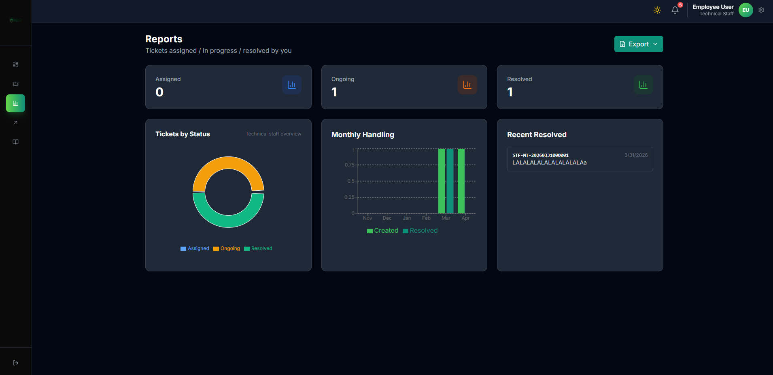
Technical Reports
Purpose: - Review personal operational metrics (assigned, ongoing, resolved).

1.10 10. Settings Module
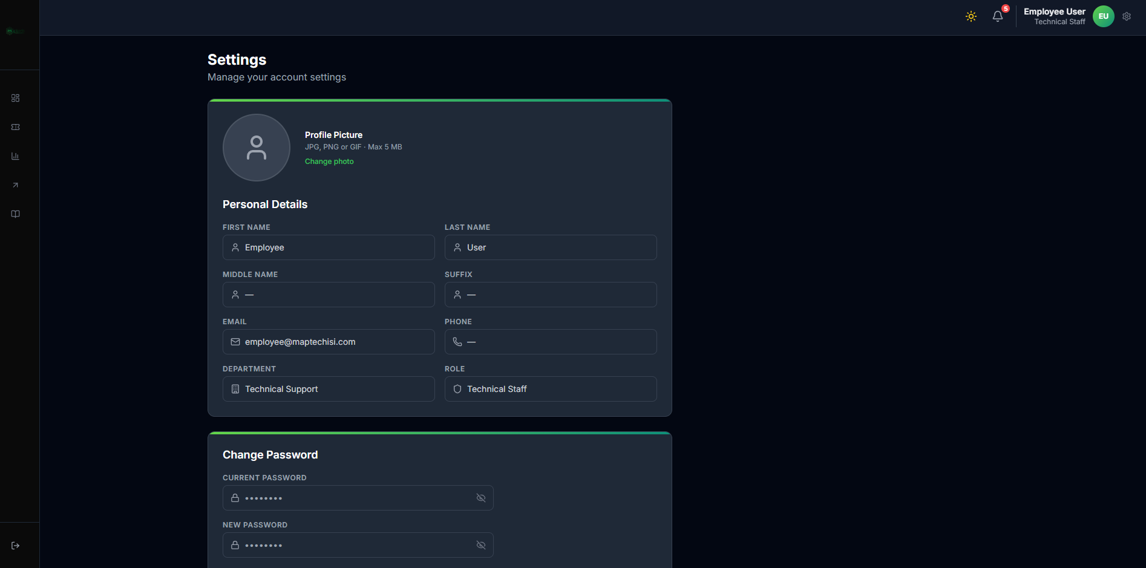
Technical Settings
Purpose: - Update personal profile and change account password.

1.11 11. Notifications Module
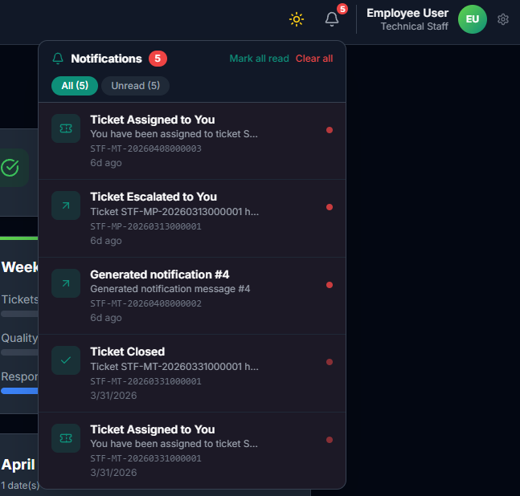
Technical Notifications
Purpose: - Receive real-time assignment, escalation, and status updates.
Usage: 1. Open bell icon panel. 2. Check unread ticket-related alerts. 3. Open relevant ticket directly from notification.

1.12 12. Data Quality Rules for Technical Staff
- Keep action remarks precise and chronological.
- Upload clear resolution proof before closure request.
- Avoid closure request with incomplete fields.
- Escalate early when issue exceeds authority or capability.

1.13 13. Technical End-to-End Summary
Flow Line R1: Assignment received.
Flow Line R2: Investigation and execution started.
Flow Line R3: Work evidence documented and uploaded.
Flow Line R4: Closure requested or escalation submitted.
Flow Line R5: Supervisor reviews closure request and confirms final decision.
Flow Line R6: Ticket is finalized as Closed or returned for further action.

1.14 14. Technical Resolving Ticket Workflow (Per Module)
Module Line M1 (Dashboard): Identify priority and SLA urgency before starting work.
Module Line M2 (Assigned Tickets): Execute diagnosis and document every key action.
Module Line M3 (Escalation): Route blocked tickets quickly with clear context.
Module Line M4 (Knowledge Hub): Reuse historical fixes to shorten resolution time.
Module Line M5 (Notifications): Respond immediately to reassignment and closure feedback events.

